**CSE 115 Bonus Assignments on if-else, switch-case**

**1.** Write C Program to calculate the tax from salary using the following table. The formula for tax is: tax = (base tax) + (percentage of excess)*(salary – min. salary in the salary range). For e.g., if the salary is 32000, then tax=5400+(22/100)*(32000-30000) = 5400+440=5840.

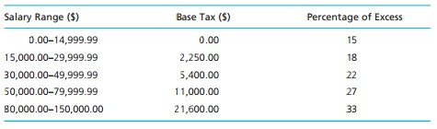

**2.** Write a C program that reads the semester no. of a student and print a comment about student based on the table below. Use if - else if - else.

|  |  |
| --- | --- |
| **Semester No.** | **Comment** |
| 0 | Invalid Semester |
| 1-3 | Freshman |
| 4-6 | Sophomore |
| 7-9 | Junior |
| 10-12 | Senior |
| >12 | You must graduate soon |

**3.** Solve the above problem using switch-case.

**4.** Write a C program that reads the first letter of direction (North, South, East, West), current (x,y) coordinate, and advancement of a person and prints the new coordinate. For e.g., if the current coordinate of a person in X- Y plane is (2,3) and s/he advances 6 units towards North, then his/her new coordinate is (2,3+6)=(2,9). Sample input/output (bold ones are user inputs):

Enter current coordinate (x and y positions): **2 3**

Enter No. units towards direction: **6**

Enter Direction: **N**

New coordinate: (2,9)

**5.** Solve question#4 using switch-case.